## A PROJECT REPORT ON

**“SYSTEM SURVEILLANCE USING KEYLOGGER”**

**Project ID: (AI-27/2022-23)**

**For the Degree of**

**Bachelor of Technology in Department of Computer Science and Engineering**

**(Artificial Intelligence)**

## SUBMITTED BY:

|  |  |
| --- | --- |
| **Aman Javed Maner** | **(2164191913028)** |

**UNDER THE GUIDANCE OF**

## Prof. Harshal Mahajan



Department Of Computer Science and Engineering

( Artificial Intelligence )

## PCET- NMVPM’s,

**Nutan College of Engineering and Research, Talegaon, Pune**

***“Vision of the Institute”***

***“***To be a leading technological institute ensuring quality education giving rise to innovative technocrats, professionals and global citizens.***”***

## 2022-2023

**SEAL**

Nutan Maharashtra Vidya Prasarak Mandal’s

### NUTAN COLLEGE OF ENGINEERING AND RESEARCH

Under Administrative Support of Pimpri Chinchwad Education Trust

# CERTIFICATE

This is to certify that the Project Report entitled **“System Surveillance using Keylogger”**, which is being submitted by, Mr. Aman Javed Maner as partial fulfillment for the Degree of Bachelor of Technology ( Computer Science and Engineering – Artificial Intelligence Department ) of **DBATU, Lonere**

This is bonafide work carried under my supervision and guidance.

Place: Pune Date: / /2023

|  |  |  |
| --- | --- | --- |
| **Prof. Harshal Mahajan Project Guide** | | **Prof.**  **Project I/C** |
| **Prof. Priyanka Vyas Head of Department** | **Dr. Aparna Pande Principal** |

### External Examiner

# ACKNOWLEDGEMENT

The satisfaction & euphoria that accompany the successful completion of any task would be incomplete without the mention of people who made it possible . So I acknowledge all those whose guidance and encouragement served as a beacon light & crowned my efforts with success.

I have immense pleasure in expressing thanks to the principal **Dr. Aparna Pande** for providing all the facilities for the successful completion of the project.

With due respect, I thank my H.O.D. **Prof. Priyanka Vyas** Department of Computer Science and Engineering ( Artificial Intelligence ), for her motivating support, keen interest which kept my spirits alive all through.

I would like to express thanks to my guide **Prof. Harshal Mahajan ,** Department of ‘Computer Science and Engineering ( Artificial Intelligence )’ who has guided me throughout the completion of this project.

Finally I would like to thank all the teaching and non-teaching staff and all my friends who have rendered their support in the completion of this report.

**Name and Signature of student:**

|  |  |  |
| --- | --- | --- |
| **Roll.no** | **Name** | **Sign** |
| 27 | Aman Javed Maner |  |

**ABSTRACT**

In many companies now-a-days data security and data recovery is the most important factor. So there are many cases where data recovery is required. For these kinds of problems keylogger is one of the best solutions which is often referred to as keylogging or keyboard capturing.

Keyboard capturing is the action of recording the keys stroke on a keyboard, typically covertly, so that the person using the keyboard is unaware that their actions are being monitored. Using keylogger application users can retrieve data when working file is damaged due to several reasons like loss of power etc.

This is a surveillance application used to track the users which logs keystrokes; uses log files to retrieve information. Using this application we can recall forgotten email or URL. In this keylogger project, whenever the user types something through the keyboard, the keystrokes are captured and mailed to the mail id of admin without the knowledge of the user within the time set.

Keywords: *Keylogger, System Surveillance , Keystrokes, Capturing data , Keyboards*

## INDEX

|  |  |  |
| --- | --- | --- |
| **Sr.**  **No.** | **Content** | **Page No.** |
| 1 | Introduction | 7 |
| 1.1 | History | 7 |
| 1.2 | Literature Review | 8 |
| 1.2 | Problem Statement | 10 |
| 1.3 | Objectives | 11 |
| 2 | Methodology | 12 |
| 2.1 | Programming Environment | 12 |
| 2.2 | Program Files Used | 12 |
| 2.3 | Modules Used | 13 |
| 3 | Program Context | 14 |
| 3.1 | Scope of Developing the Project | 14 |
| 3.2 | Problem Identification | 15 |
| 3.3 | Project Function | 15 |
| 3.4 | Operating Environment | 16 |
| 4 | Code Implementation & Testing: | 17 |
| 4.1 | Source Code | 17 |
| 4.2 | Output (Testing) | 20 |
| 5 | Conclusion | 22 |
|  | References | 23 |

**LIST OF FIGURES**

|  |  |  |
| --- | --- | --- |
| **Fig. No.** | **Figure Name** | **Page No.** |
| 2.1 | Keylogger Architecture | 12 |
| 2.2 | Graphical Representation of how Keylogger Works | 13 |
| 3.1 | Increased use of keylogger | 14 |
| 3.2 | Kernel Based Keylogger | 15 |
| 3.3 | Keylogger Process in User Activity | 16 |
| 4.1 | Source Code 1 | 17 |
| 4.2 | Source Code 2 | 18 |
| 4.3 | Source Code 3 | 18 |
| 4.4 | Source Code 4 | 19 |
| 4.5 | Output 1 | 20 |
| 4.6 | Output 2 | 20 |
| 4.7 | Output 3 | 21 |
| 4.8 | Output 4 | 21 |

1. **INTRODUCTION**

In many IT infrastructure organizations now-a-days, data security and data recovery are the most important factors which is basically deployed in Computer Forensics. Computer forensics consists of the art of examining digital media to preserve, recover and analyze the data in an effective manner. There are many cases where data recovery is required essentially. So by using keylogger application users can retrieve data in the time of disaster and damaging of working file due to loss of power etc. Keyloggers are specially effective in monitoring ongoing crimes. This is a surveillance application used to track the users which log keystrokes, uses log files to retrieve information, capture a record of all typed keys. The collected information is saved on the system as a hidden file or emailed to the Admin or the forensic analyst.

**1.2 LITERATURE REVIEW**

# Keylogger Surveillance Software [1]-

Authors:- Ediga Komal Goud , Gadekari Rohith Reddy

A Keylogger is a spyware tool used to record targets movements. Keystroke are forensic technology used to monitor and record every keystroke written on a computer .Keylogging often used as a hacking tool by black hat hackers to steal login details of an employee and confidential company information. Keylogging presents a special challenge to security managers In contrast to customary worms and infections, particular sorts of keyloggers are everything except difficult to identify. Programming keyloggers are exceptionally well known instrument which are in many cases used to reap secret data. One of the fundamental purposes behind this fast development of keyloggers is the opportunities for unprivileged programs running in client space to snoop and screen every one of the keystrokes composed by the clients of a framework. Execution and Dissemination of these sort of keyloggers are exceptionally simple due to the capacity to run in unprivileged mode. However, simultaneously, permits one to comprehend and demonstrate their conduct exhaustively.

# User activity monitoring using keylogger [2]-

# Authors:- R. Venkatesh , K. Raja Sekhar

# In all industries in trade in these days, desktops and IT sectors are a giant and indulging infrastructure. Employees in all divisions from HR to program progress expect a computing device and/or network connector as a way to do their jobs effortlessly. Still people in the field are needed to hold a desktop or several form of the hand held the device to broadcast information. This approach to the arena has introduced a quantity of recent protection associated subject to the work drive. One of the crucial matter includes the manufacturer's proper to keep manage over InfoTech and educational institutes belongings which furnish staff with an opportunity to silently execute private events. There are over hundred's entirely unexpected stock realistic now a days that might let organizations notice what their clients act at job on their desktops, of their e-mail and on cyberspace. However what do such statistics fairly represent? What do organization keep an eye on of user/employee electronic message, web and PC utilization truly look like? In this study, we provide a survey results conducted on both students and staff in our college and explanation of why you need to monitor your employees, concept of key loggers and the client server based interception of keyloggers. The key logging project captures all strokes of keys along with the title of the appliance where in the keystrokes had been pressed. Using this, we seizing all knowledge in textual content and photo type.

# A new approach to cyber security through keylogger [3]-

# Authors:- Thanapal Pandi , T. Muthamil Selvan , John Prabhu , Tahreem Rajput

# A program that infect computers, destroy the data, steal personal information, get some valuable information, we focus on a particular kind of malware that is key logger. A keylogger monitors a user input and keeping a log of all keys that are pressed. There are various tracking techniques such as computer monitoring, software key stroke recorder, key stroke logger, Keyboard sniffer and snoop ware, they can track virtually any running program on a system. Some of the keylogger known as screen scrapers. This takes the snapshot of the screen. It can be defined two category hardware and software keylogger. Hence we are working on software keylogger which are monitoring on windows operating system. In this when a user performing an event (pressing a key) in the windows operating system, the keyboard driver of the operating system translate a key stroke in to a windows message is called "wm_keydown". There are four main methods developing keylogger keyboard state table method, windows keyboard hook method, kernel-based keyboard filtering driver method. in this paper we used a new method getkeystate, that is variation of windows keyboard hook method, which is unique to windows message mechanism.

# Keyloggers: silent cyber security weapons [4]-

# Authors:- Akashdeep Bhardwaj , Sam Goundar

# Cyber attackers are always seeking to design and push malicious software programs to unsuspecting users, to intentionally steal or cause damage and exploit data on end user systems. Malware types include spyware, keyloggers, rootkits and adware. In the past, script kiddies hacked computers to show off their skills and have fun. Today, hacking computers has become a huge cybercrime industry. Even as systems have improved in terms of both hardware and software, cyber attacks continue unabated. The privilege level at which keyloggers execute is higher than typical malware, which makes them almost impossible to detect and remove. Dr Akashdeep Bhardwaj of the University of Petroleum & Energy Studies, Dehradun, and Dr Sam Goundar of the University of South Pacific, demonstrate how a keylogger can gather keystrokes and screenshots along with online transactions without a scanner being able to detect it. They also suggest a form of virtual keyboard that could defeat this kind of malware.

# Advanced Keylogger- A Stealthy Malware for Computer Monitoring [5]-

# Authors:- Aarushi Dwivedi , Krishna Tripathi , M.L. Sharma

Modern society is far more dependent on electronic devices than the previous generations. This dependency has both pros and cons. Although the list of pros is endless, they can easily be outweighed by one con which is being vulnerable to malicious programs. Keylogger is one such malware. Earlier, the prime focus was just limited to recording keystrokes made by a user but now are known for incorporating a multitude of features. Keyloggers are used to steal confidential information covertly and their detection is not quite simple since they execute completely in stealth mode. In this exposition, an advanced software keylogger is proposed which is compared with the existing keyloggers based on two criteria, first being the number of features incorporated and second, the CPU usage while the keylogger is being executed. The evaluation posits that the proposed keylogger contains more features with keeping the CPU usage to minimum hence making it difficult to be detected by the user.

### 1.3 PROBLEM STATEMENT

The main purpose of this document is to illustrate the requirements of the project Keylogger. Now- a-days IT business infrastructures are mostly in need of the cyber security factor that is Computer Forensics. Keyloggers can effectively assist a computer forensics analyst in the examination of digital media.

Keystroke loggers are available in software and hardware form, and are used to capture and compile a record of all typed keys. The information gathered from a keystroke logger can be saved on the system as a hidden file, or emailed to the forensic analyst or the Administrator. Generic keystroke loggers typically record the keystrokes associated with the keyboard typing. Advanced keystroke loggers have many additional features. Our project keylogger has the following features;

* Monitors Keystrokes
* Sends mail to the Admin’s mail Id
* Logs keystrokes including special keys

Keyloggers have the advantage of collecting information before it is encrypted; thus making a forensic analyst’s job easier. Most keyloggers show no signs of any intrusion within the system allowing for them to gain typed information without anyone having knowledge of its actions except the user who use it. Keyloggers incorporate a wide array of cyber security issues and provide a practical approach to understand topics such as attacker goals, varieties of malware and their implementation, the role of malware in infecting and how stealth is archived in an infected system.

### PROBLEM STATEMENT

Development of Keylogger

### 1.4 OBJECTIVES

* + 1. The main objective of this application is to keep tracks on every key that is typed through the keyboard
    2. And send it to the admin through the mail server in the time set or given.
    3. It provides confidentiality as well as data recovery to all the IT infrastructures in need.

## 2. METHODOLOGY

## 

### 2.1 Programming Environment

1. Python 3.8.0

Python 3.8.0 is a specific version of the Python programming language released in October 2019. It introduces new features and optimizations, improving the language's functionality and performance. Python 3.8.0 includes enhancements such as assignment expressions, positional-only parameters,and improved syntax and debugging capabilities.

1. PyCharm

PyCharm is an integrated development environment (IDE) for Python programming. It provides a comprehensive set of tools for coding, debugging, and testing Python applications. PyCharm offers features like code completion, syntax highlighting, version control integration, and a user-friendly interface.

## 

## 2.2 Program Files Used

i. Keylogger.py

ii. Execute_keylogger.py

## 

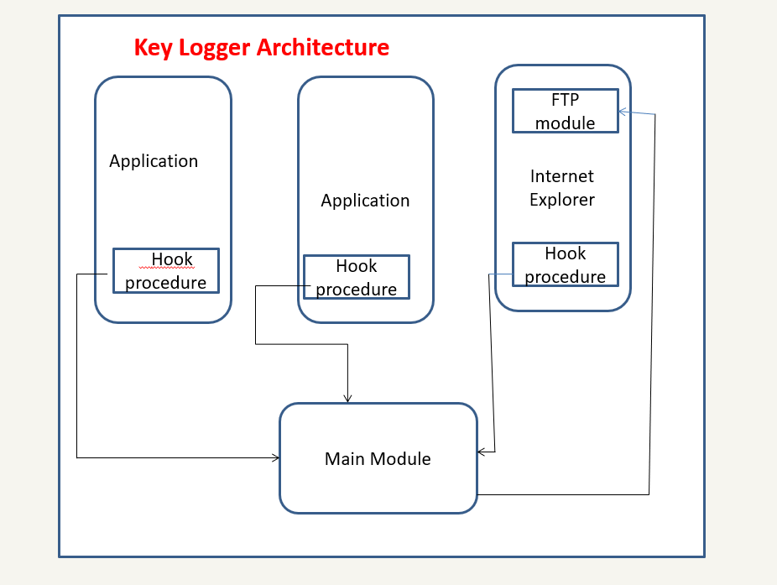

*Fig No. 2.1: - Keylogger Architecture*

**2.3 Modules Used**

1. **Smtplib**

The module included in python defines an SMTP client session object that can be used to send mail to any internet machine with an SMTP listener daemon.

1. **Threading**

It is one of the modules provided with python includes a simple-to-implement locking mechanism that allows you to synchronize threads.

1. **Pynput**

This library allows the users to control and monitor input devices.

e.g.; pynput.mouse, pynput.keyboard.

### 

### 

*Fig No. 2.2: - Graphical Representation of how Keylogger Works*

### 3. Project Context

## 

## 3.1 Scope of Developing the Project

Keylogger is basically using keystroke logs to monitor the system and send the details to the admin through the mail server.Keyloggerss provide the best solutions in case of such cases like; IT organizations can indicate their concerns by going after the culprit whose performance is deteriorating that of the whole organization, parents can maintain a check on their children’s activities, a particular person’s activities can be monitored, storing passwords of various social media profiles.

Above all, keylogger is one of the best implementation of fundamentals of ethical hacking. By using this some measures could be done accordingly that would save personal data from being in the hands of total strangers.

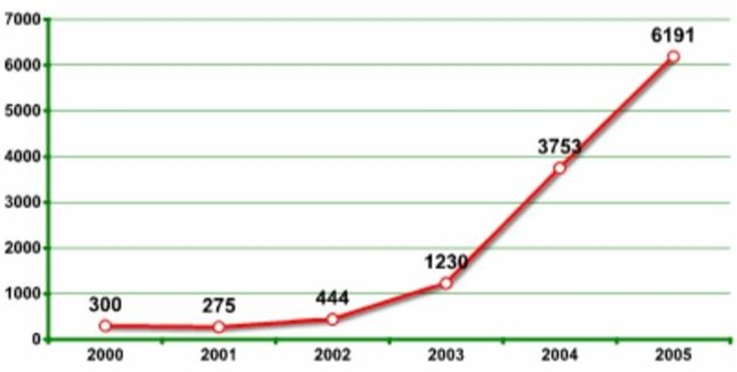

*Fig No. 3.1: - Increased use of keylogger*

### 3.2 Problem Identification

Hackers and other third parties are always looking for the vulnerabilities present inside the system. To gain knowledge about what they require from the organizations, they either gain access to the confidential data stored in the system and either cause harm to the integrity of data or may cause data loss. Another problem is that cyber crimes are increasing day by day. If we will have the chat logs or keystroke logs of victim’s laptop then we can easily analyze the entire planning of the victim which will provide the best solution to eradicate or solve the problem.

**3.3** **Project Function**

Authorized use of a keylogger is use of such software with the knowledge and consent of the PC Owner or security administrator. As a rule, authorized monitoring software products require physical access to computer and administrative privilege for configuration and installation that excludes (or at least minimizes) risks of unauthorized use of programs. As per the rule, such software products have ability to obtain and configure a “packed” installation executable file that is delivered to the user’s computer with the help of various ethical and authorized schemes. During installation it doesn’t display any messages or create any windows on the screen.

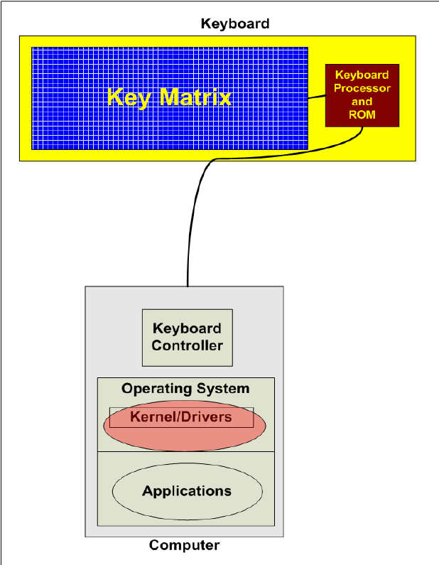

*Fig No. 3.2: - Kernel Based Keylogger*

**3.4** **Operating Environment**

The product will be operating in windows, Linux environment. The hardware configuration include Hard Disk: 40 GB, Monitor: 15” Color monitor, Keyboard: 122 keys. The basic input devices required are keyboard, mouse and output devices are monitor, mobile devices etc.

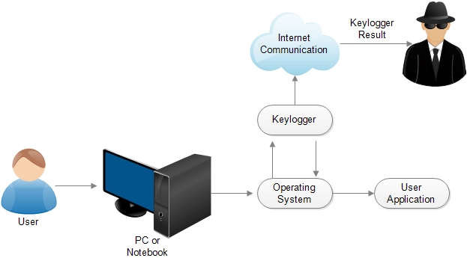

*Fig No. 3.3: - Keylogger Process in User Activity*

**4. Code Implementation & Testing:**

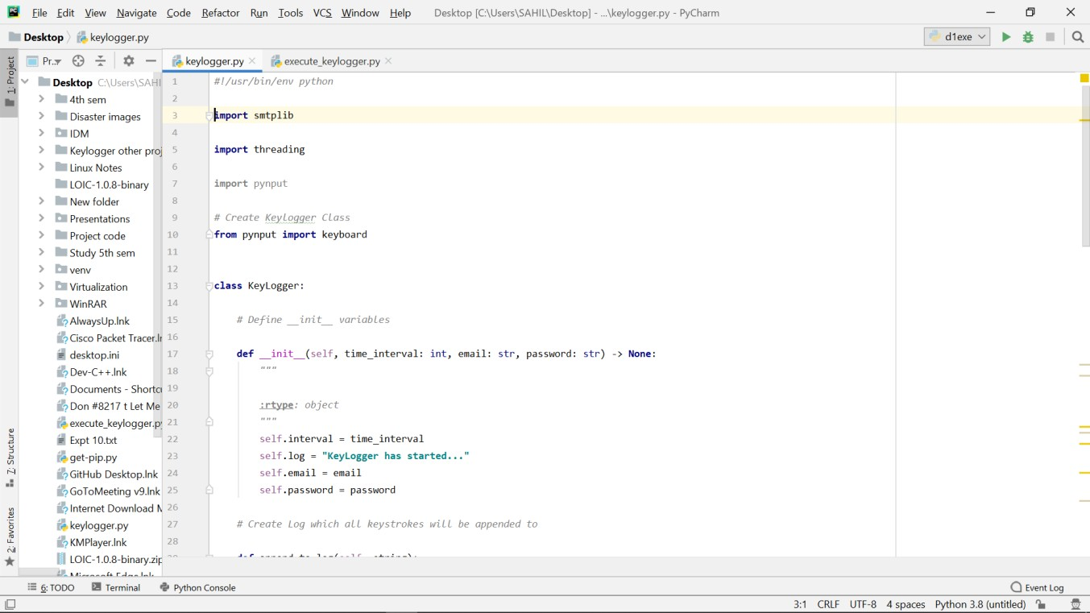**4.1 Source Code**

*Fig No. 4.1: - Source Code 1*

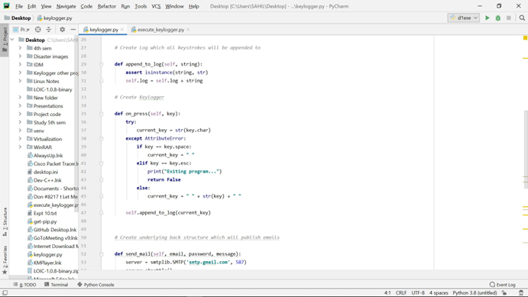

*Fig No. 4.2: - Source Code 2*

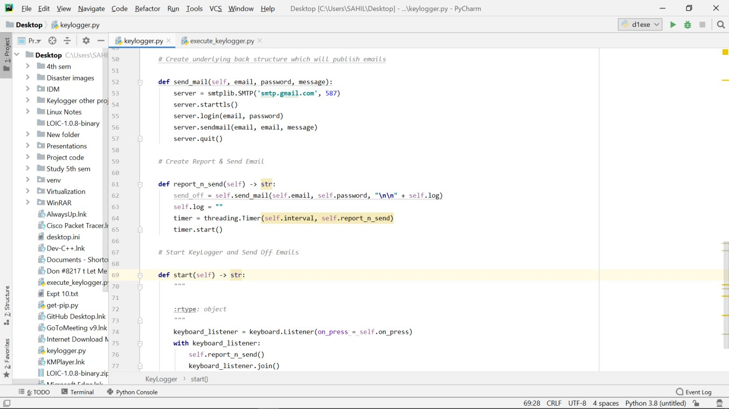

*Fig No. 4.3: - Source Code 3*

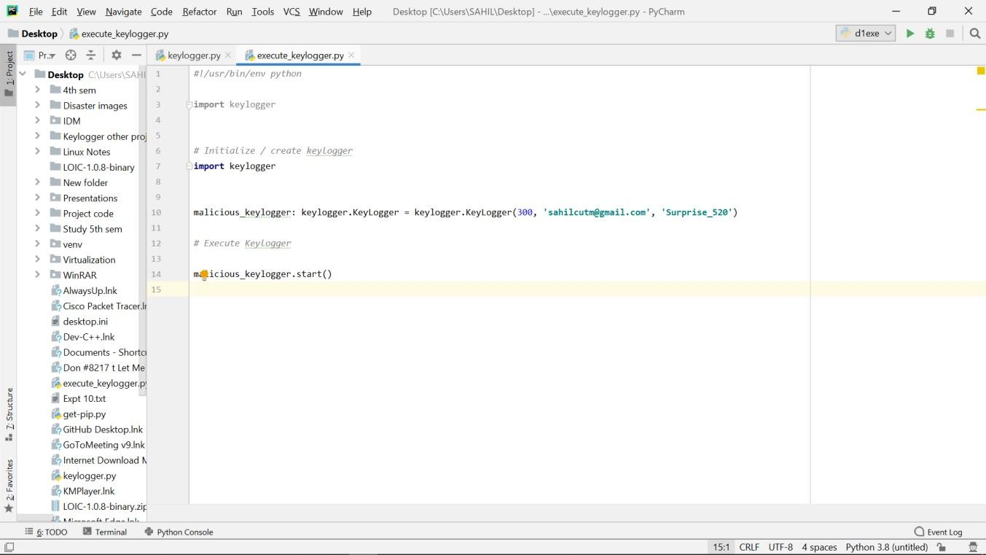

*Fig No. 4.4: - Source Code 4*

### 4.2 Output (Testing)

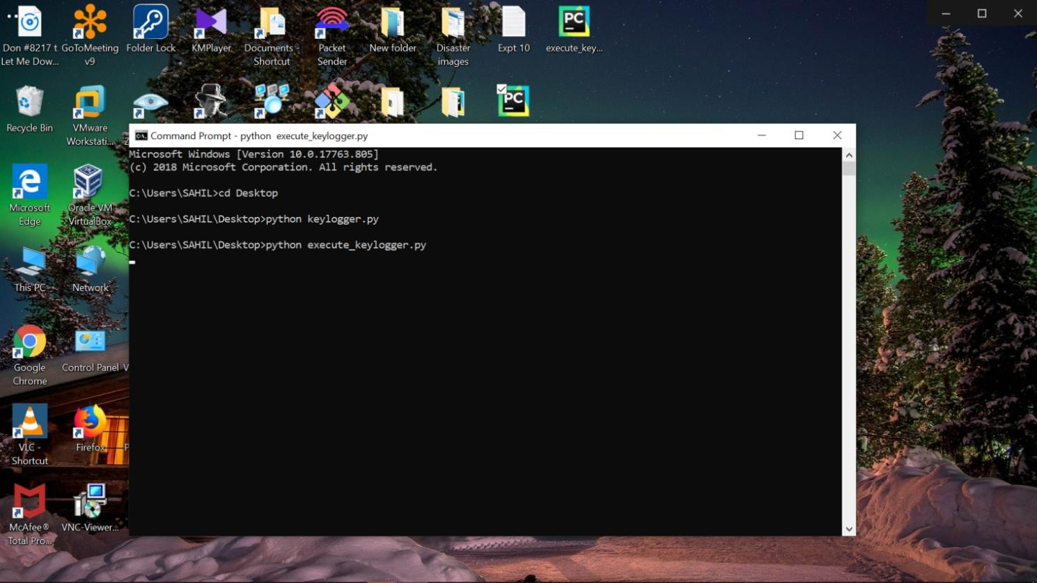

*Fig No. 4.5: - Output 1*



*Fig No. 4.6: - Output 2*

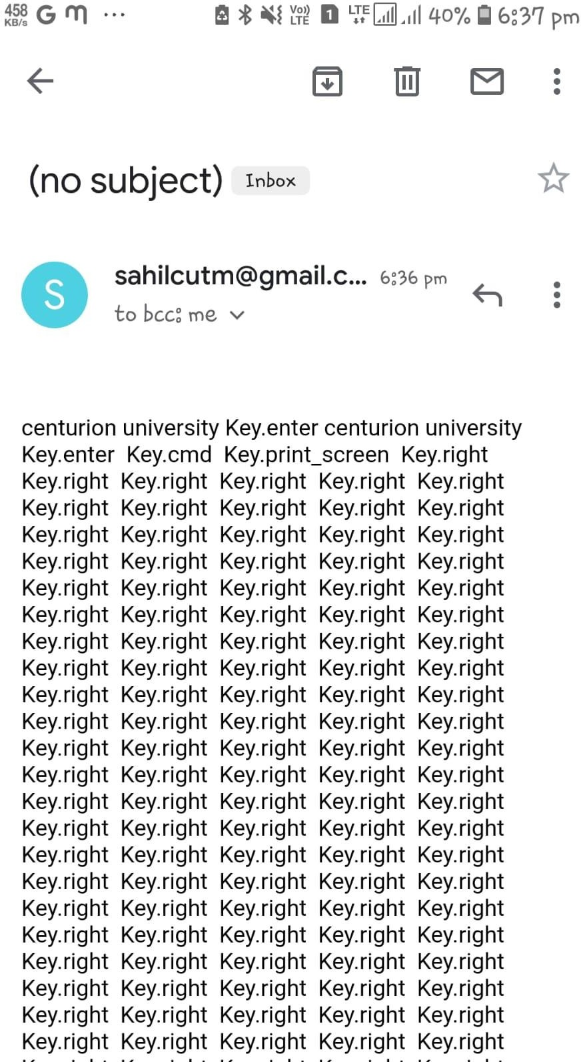

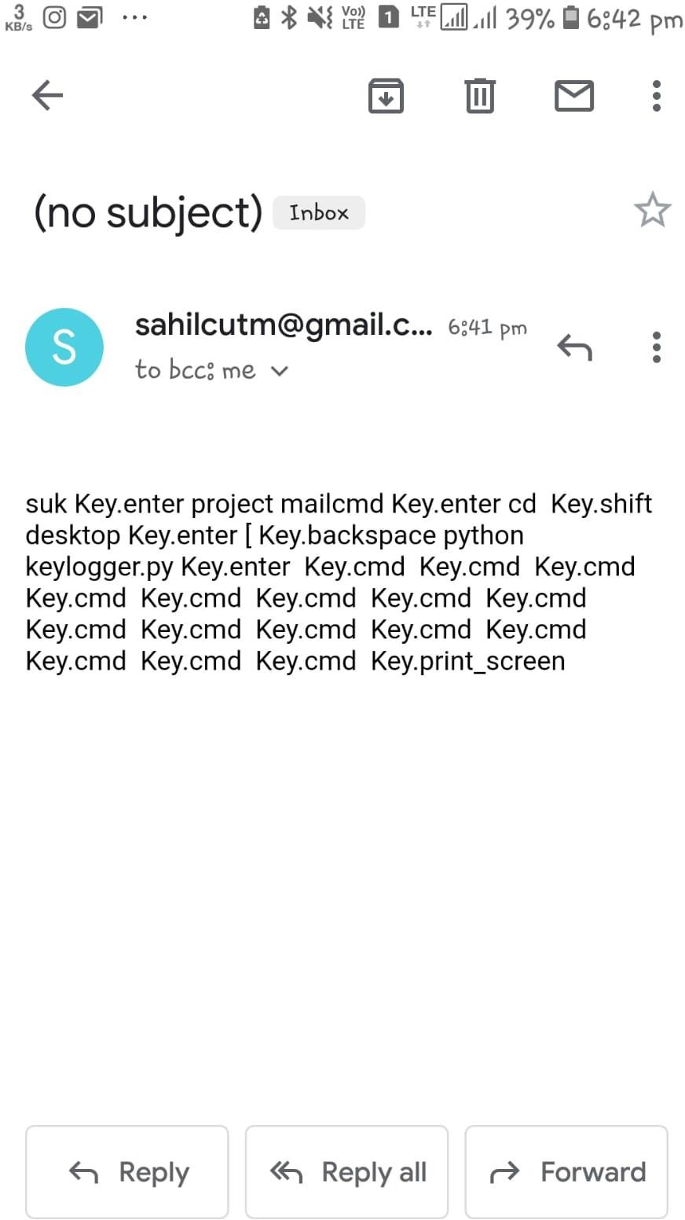

*Fig No. 4.7: - Output 3 Fig No. 4.8: - Output 4*

## 5. CONCLUSION

A Keylogger is a form of software which is used to track or log the all the keys that a user strikes on their keyboard, usually in secret so that the user of the system doesn’t know that their actions are being monitored. It is otherwise known as keyboard capturer. These are perfectly legal and useful. They can be installed by employers to oversee the use of their computers, meaning that the employees have to complete their tasks instead of procrastinating on social media. Some of the possible amendments and improvements in this project are;

* + Adding screenshots of pages visited
  + Recording of system screen
  + Full remote cloud monitoring
  + Screenshot of immediately changed pages
  + Secure web account for data storing
  + Password Protection
  + Parental Control

## REFERENCES

[1] Ediga Komal Goud , Gadekari Rohith Reddy"Keylogger Surveillance Software," IJRASET - International Journal for Research in Applied Science and Engineering Technology, [Online].

[2] R. Venkatesh , K. Raja Sekhar, "User activity monitoring using keylogger," Int. J. Comput. Appl., vol. 162, no. 2, pp. 1-5, Jul. 2017.

[3]Thanapal Pandi, T. Muthamil Selvan , John Prabhu, Tahreem Rajput, "A new approach to cyber security through keylogger," Int. J. Emerg. Technol. Adv. Eng., vol. 6, no. 6, pp. 276-279, Jun. 2016.

[4] Akashdeep Bhardwaj, Sam Goundar, "Keyloggers: silent cyber security weapons," Network SecurityVol. 2020, No. 2, Published Online:3 Nov 2021.

[5] Aarushi Dwivedi,Krishna Chandra Tripathi,M.L. Sharma , "Advanced Keylogger: A Stealthy Malware for Computer Monitoring," in Proceedings of the International Conference on Cybersecurity (ICCS), pp. 123-130, 2022.